

**ATTENDANCE USING**

**AI FACE RECOGNITION**

*A project submitted in partial fulfillment of the requirements for the award of the degree of*

***Supervised by:***

*Dr. Sourabh Jain*

**Bachelor of Technology in**

**COMPUTER SCIENCE AND ENGINEERING**

***Submitted by:***

*Rohit Raj*

*12011035 (CSE)*

**SELF DECLARATION**

I hereby declare that work contained in the project file titled “ATTENDANCE USING FACE RECOGNITION” is original. I have followed the standards of research/project ethics to the best of my abilities. I have acknowledged all sources of information which I have used in the project.

**Name**: Rohit Raj

**Roll No.**: 12011035

Department of Computer Science and Engineering,

Indian Institute of Information Technology,

Sonipat, Haryana, PIN: 131029, India

**CERTIFICATE**

This is to certify that Mr. Rohit Raj has worked on the project entitled “ATTENDANCE USING FACE RECOGNITION” under my supervision and guidance. The contents of the project, being submitted to the Department of Computer Science and Engineering, IIIT Sonipat, for the award of the degree of B.Tech in Computer Science and Engineering, are original and have been carried out by the candidate himself. This project has not been submitted in full or part for the award of any other degree or diploma to this or any other university.

Dr. Sourabh Jain

Supervisor

Department of Computer Science and Engineering,

Indian Institute of Information Technology,

Sonipat, Haryana, PIN: 131029, India

**ACKNOWLEDGEMENTS**

We would like to express our special thanks of gratitude to our teacher (Dr. Sourabh Jain) who gave us the golden opportunity to do this wonderful project on the topic ATTENDANCE USING FACE RECOGNITION which also helped us in doing a lot of Research and we came to know about so many new things we are really thankful to them. Secondly, we would also like to thank our parents and friends who helped me a lot in finalizing this project within the limited time frame. We are overwhelmed in all humbleness and gratefulness to acknowledge my depth to all those who have helped us to put these ideas, well above the level of simplicity and into something concrete. Any attempt at any level can't be satisfactorily completed without the support and guidance of my parents and friends. We would like to thank our parents who helped me a lot in gathering different information, collecting data and guiding me from time to time in making this project, despite of their busy schedules, they gave me different ideas in making this project unique. Thanking you,

Rohit Raj, Abhishek Kumar Shah

12011035, 12011031

**ABSTRACT**

Name of the student: **Rohit Raj**

Roll No.: **12011035**

Degree for which submitted: **B.Tech (CSE)**

Department of **Computer Science and Engineering, IIIT Sonipat**

Project Title: **ATTENDANCE USING AI FACE RECOGNITION**

Name of the thesis supervisor: **Dr. Sourabh Jain**

Month and year of project submission: **May 2022**

A face recognition attendance system makes use of facial recognition technology to identify and verify a person and mark attendance automatically.

Fingerprint scanning systems are almost the standard for attendance systems but recent struggle with the pandemic has brought forth the issue with systems that require physical contact. A facial recognition attendance system is a contactless technology that provides freedom from any physical interaction between the man and the machine.

It is much easier to understand how attendance systems with face recognition can make buildings and premises safer and efficient if we know how the technology works

Attendance using Face Recognition

Rohit Raj Abhishek Kumar Shah

12011035 (CSE) 12011031 (CSE)

IIIT Sonipat IIIT Sonipat

1. **INTRODUCTION**

Face recognition is branch of AI which recognises people based on their faces. Face recognition systems can be used to identify people in videos, photos in real-time.

With the use of algorithms, computers pick out specific, distinctive details about a person's face. These details which include the distance between the eyes or shape of the chin etc., are then converted into a mathematical representation and then is compared to data on known faces in a face recognition database. The data about a particular face is often called a face template and is distinct from a photograph because it’s designed to only include certain details that can be used to distinguish one face from another. [1]

Human brains are pre-programmed to do all of this automatically and instantly. Computers on the other hand are not capable of this kind of high-level generalization, so computers need to be taught how to do each step in this process separately.

Face attendance works by verifying the face against the enrolled face to mark the daily attendance. All one needs is to stand in front of the camera and the face is verified instantly, usually in milliseconds.

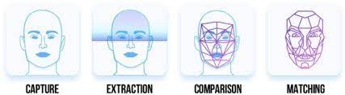

1. **OBJECTIVE**

Nowadays more people prefer to automate their work. But the process of recording an individual’s attendance is still manual, which is quite slow, inefficient and time consuming.

So, instead of using the conventional methods i.e., manually taking the records, this proposed system aims to develop an automated system that records the attendance by using facial recognition technology. The main objective of the project is to offer system that simplify and automates the process of recording a

Figure 1 Working of face recognition [2]

and tracking attendance by utilizing facial recognition technology. The system can make the attendance marking and management system **efficient, time saving, simple and easy**.

1. **WORKING** [2]

Face recognition is really a series of several related problems:

1. First, look at a picture and find all the faces in it
2. Second, focus on each face and be able to understand that even if a face is turned in a weird direction or in bad lighting, it is still the same person.
3. Third, be able to pick out unique features of the face that one can use to tell it apart from other people— like how big the eyes are, how long the face is, etc.
4. Finally, compare the unique features of that face to all the people already in database to determine the person’s name.

It is required to build a *pipeline* where one will solve each step of face recognition separately and pass the result of the current step to the next step. In other words, chain together several machine learning algorithms:

**Step 1: Finding all the Faces**

The first step is face detection. One needs to locate the faces in a photograph before we can try to tell them apart!

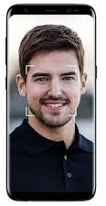

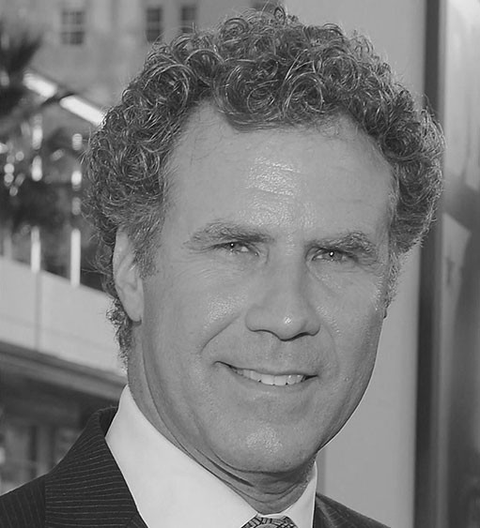Figure 2 Face detection [2]

Figure 3 Sample of a face [2]

Face detection is a great feature for cameras. When the camera can automatically pick out faces, it can make sure that all the faces are in focus before it takes the picture. But it will be used for a different purpose i.e., finding the areas of the image one wants to pass on to the next step in our pipeline.

In this process computer encodes a picture using the HOG algorithm to create a simplified version of the image. Using this simplified image, find the part of the image that most looks like a generic HOG encoding of a face.

To find faces in this HOG image, find the part of that image that looks the most similar to a known HOG pattern that was extracted from a bunch of other training faces:(Figure 4)  [2]

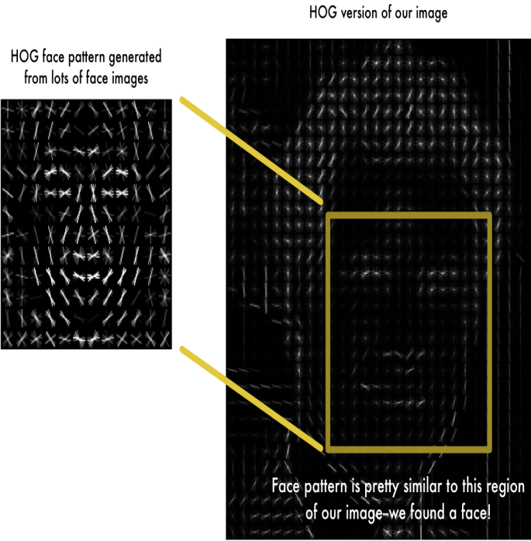

Figure 2 HOG version of image [2]

Using this technique, it becomes easy to find faces in any image. [2]

**Step 2: Posing and Projecting Faces**

Now, dealing with the problem that faces turned in different directions look totally different to a computer. To account for this, computer will try to wrap each picture so that the eyes and lips are always in the sample place in the image. For this, it is required to use an algorithm called **face landmark estimation**. [2]

The basic idea is to come up with 68 specific points (called landmarks) that exist on every face — the top of the chin, the outside edge of each eye, the inner edge of each eyebrow, etc. Then train a machine learning algorithm to be able to find these 68 specific points on any face: [2]

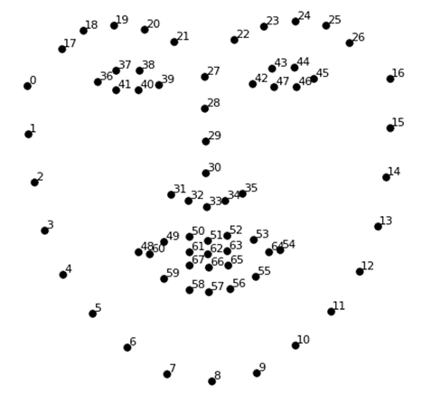

Figure3 68 landmarks the program locates on every face [2]

Now no matter how the face is turned, it is possible to centre the eyes and mouth are in roughly the same position in the image. This will make the next step a lot more accurate. [2]

**Step 3: Encoding Faces**

In this process one needs a way to extract a few basic measurements from each face. Then it is possible to measure unknown faces and find the known faces with the closest measurements. The solution is to train a Deep Convolution Neural Network to generate 128 measurements for each face. These 128 measurements of each face is called **embedding**. The training process works by looking at 3 face images at a time:

1. Load a training face image of a known person
2. Load another picture of the same known person
3. 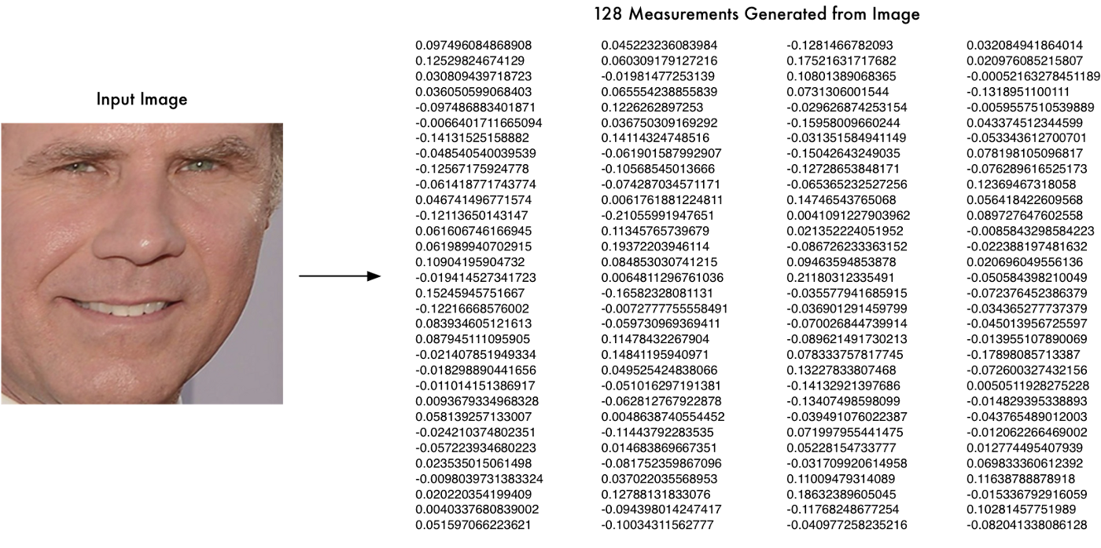Load a picture of a totally different person

Figure 4 Measurements generated from image [2]

Once the network has been trained, it can generate measurements for any face, even ones it has never seen before. All that is required is to run the face images through their pre-trained network to get the 128 measurements for each face. (Figure 6) [2]

**Step 4: Finding the person’s name from the encoding**

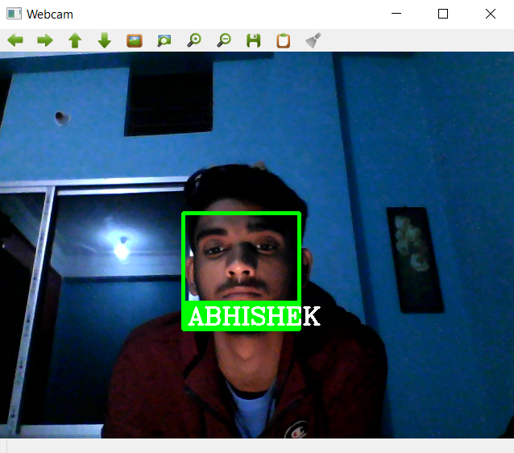In this step, find the person in the database of known people who has the closest measurements to the test image. All that is required is to train a classifier that can take in the measurements from a new test image and tells which known person is the closest match. Running this classifier takes milliseconds. The result of the classifier is the name of the person. [2]

Figure 5 Face of the person matches with that in database

1. **GUI of Face recognition app**

Discussed much about the working of face recognition technology, now moving to the designing of a GUI for the application.

GUI is a Graphical Interface that is a visual representation of communication presented to the user for easy interaction with the machine. GUI means Graphical User Interface. It is the common user Interface that includes Graphical representation like buttons and icons, and communication can be performed by interacting with these icons rather than the usual text-based or command-based communication. [3]

What is the need of GUI?

* Simplicity.
* It is visually appealing and makes anyone to get involved in working with the machine.
* Even a guy with no computer knowledge can use the computer and perform basic functions. GUI is responsible for that.

Figure 8 GUI of PyQt application

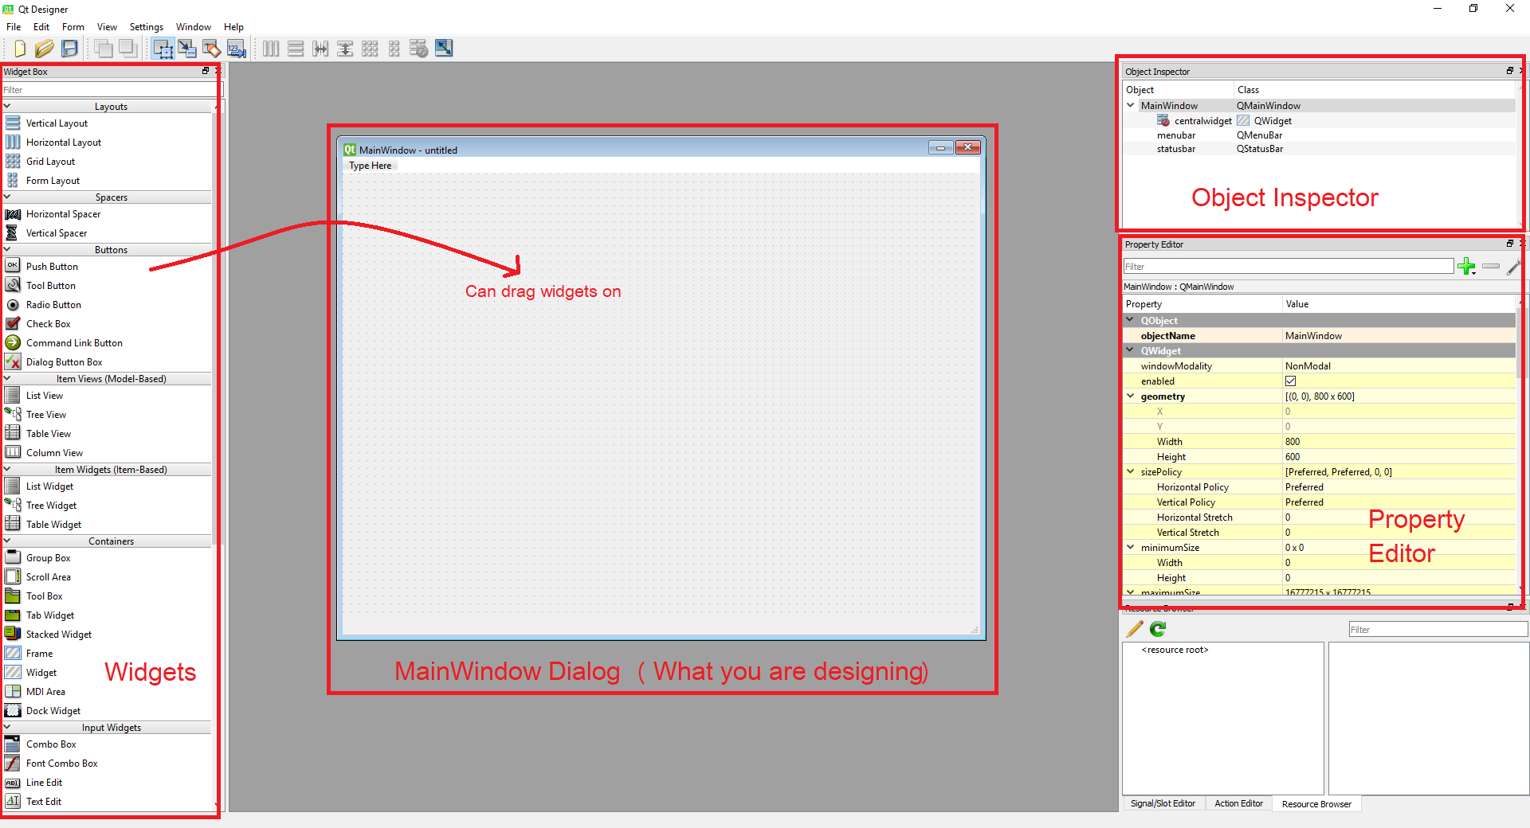

1. **WORKING**

In the project, a cross platform framework “PyQT5 GUI builder” for making a user interface has been taken into use.

PyQt connects the Qt C++ cross-platform framework with the Python language, it is a GUI module.

The principle on which a Qt class functions is related to a slot mechanism responsible for offering communication between items with the purpose of designing re-usable software components with ease.(Figure 8) [4]

1. **CONCLUSION**

This system aims to build an effective class attendance system using face recognition techniques. The proposed system will be able to mark the attendance through the face . It will detect

faces via webcam and then recognize the faces from the given database. After recognition, it will mark the attendance of the recognized student and update the attendance record. The final output should look something like this.

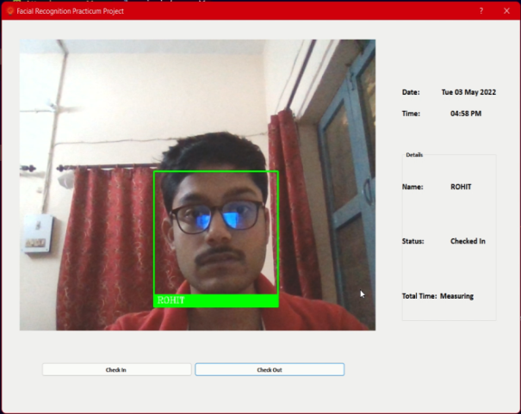

Figure 9 Final Output Screen

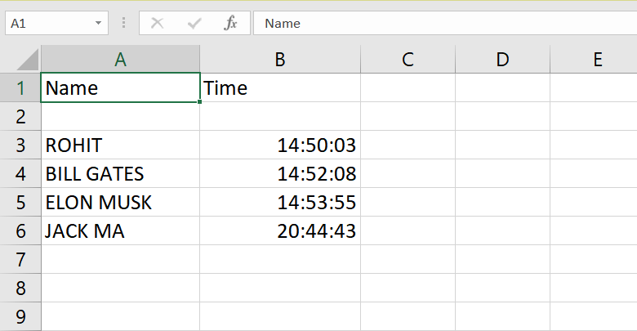The attendance sheet is updated after the recognition process, a sample is shown below. The attendance sheet shows the name of the students present in the class.

Figure 10 Names and time of check in of people stored in an excel sheet

# References

|  |  |
| --- | --- |
| [1] | “How Face Recognition works,” 17 October 2017. [Online]. Available: https://www.eff.org/pages/face-recognition. |
| [2] | A. Geitgey, “Machine Learning is Fun! Part 4: Modern Face Recognition with Deep Learning,” 24 July 2016. [Online]. Available: https://medium.com/@ageitgey/machine-learning-is-fun-part-4-modern-face-recognition-with-deep-learning-c3cffc121d78. [Accessed 27 May 2022]. |
| [3] | P. Pedamkar, “What is GUI?,” [Online]. Available: https://www.educba.com/what-is-gui/. [Accessed 28 May 2022]. |
| [4] | “What is PyQt,” [Online]. Available: https://pythonpyqt.com/what-is-pyqt/. [Accessed 28 May 2022]. |



